Pictures and Video
I can add a picture without stretching it, crop it, line it up, and trim a video clip. | ○ ○ ○
Name: ______________________________ Class: ________ Date: ____________
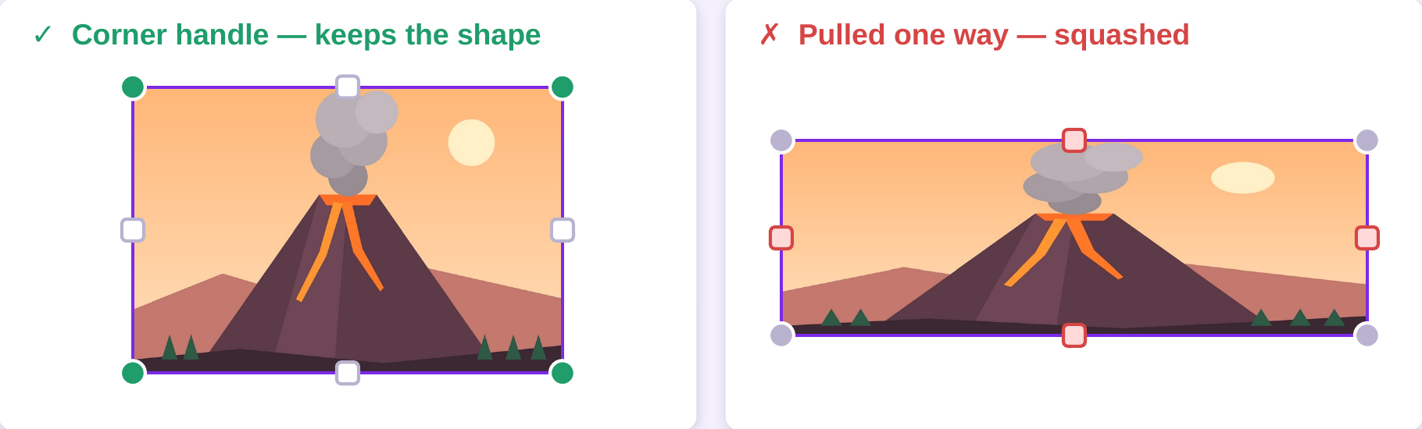
Always resize from a CORNER. If you squash one: Undo, or Ctrl + Z.
Part 1 — Pictures on pages 2, 3 and 4 (Activity 3.1)
☐ | 1 | Open your deck and go to page 2.
☐ | 2 | Click Elements on the left. Type your topic in the search box.
☐ | 3 | Find the Photos row. Click See all. Click a picture to add it.
☐ | 4 | Resize it from a CORNER handle.  ⚠ A side handle cuts the edge off a photo. To resize, use corners only.
☐ | 5 | Double-click the picture to crop it. Drag the white corners in. Click Done.  Keep only the part that helps your audience.
☐ | 6 | Drag it slowly until the pink guides appear, then let go.
☐ | 7 | Words disappeared? Right-click the picture → Layer → Send to back.
☐ | 8 | Write the picture in your Source Log (Worksheet B) NOW — not later.
☐ | 9 | Do steps 2–8 again for page 3 and page 4.
Part 2 — One video on page 5 (Activity 3.2)
☐ | 10 | Elements → search your topic → Videos. Drag one clip onto page 5.
☐ | 11 | Click the clip. Find Trim (the scissors) on the toolbar.
☐ | 12 | Drag both ends inward. Keep it UNDER TEN SECONDS. Click Done.
☐ | 13 | Press Present. Does it actually play? Press Esc to go back.
☐ | 14 | Click Notes at the bottom. Write ONE sentence: why this clip, for this audience?
☐ | 15 | Write the clip in your Source Log.

Now write it down
My topic:
My page 2 picture shows:
My video clip is:
__________ seconds long
My Notes sentence:
Challenge
★★ | Put two pictures on one page. Make them match (same size, lined up) OR make one clearly bigger. Which did you choose, and why?  _______________________________________________________________________________  _______________________________________________________________________________

★★★ | Which of your pictures shows something your words cannot? Explain in one sentence.  _______________________________________________________________________________

